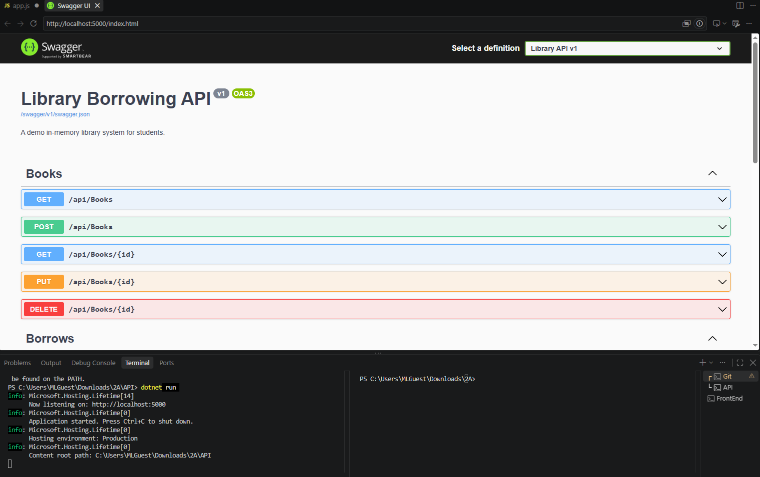

Part - 02 - showtoast

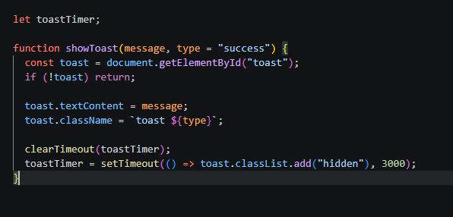

Early -01- toast
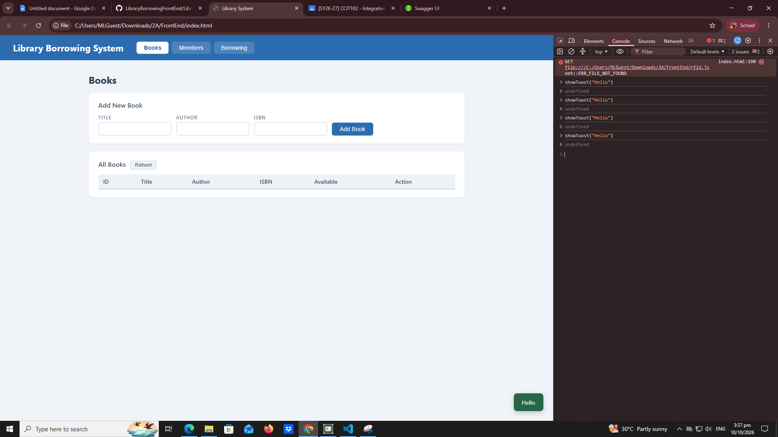

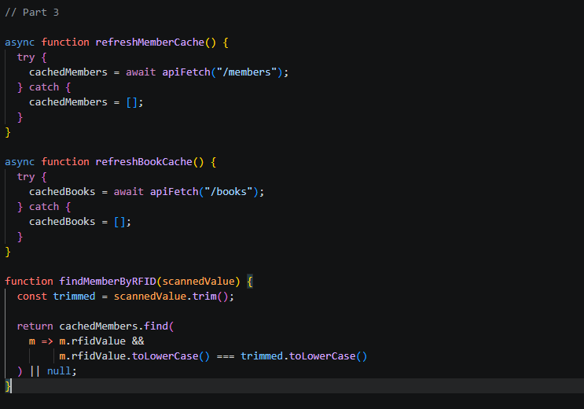
Part - 03 - caches
Early - 02 - cache - console

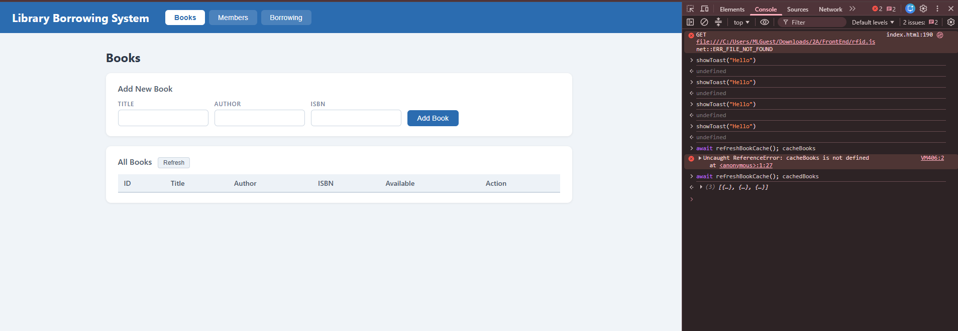

part-04-tabs-refresh
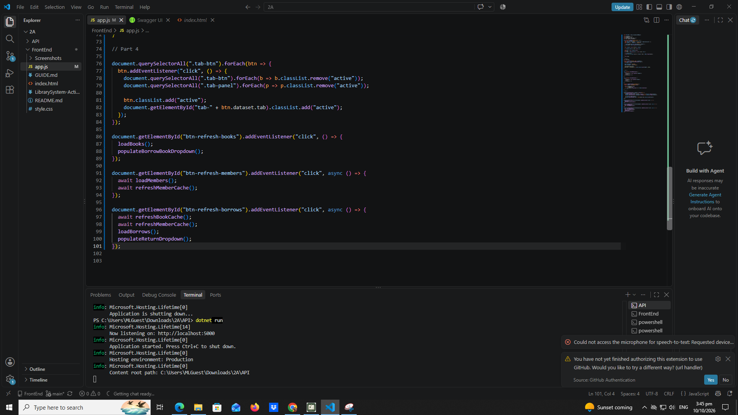

Early-03- tab- refresh
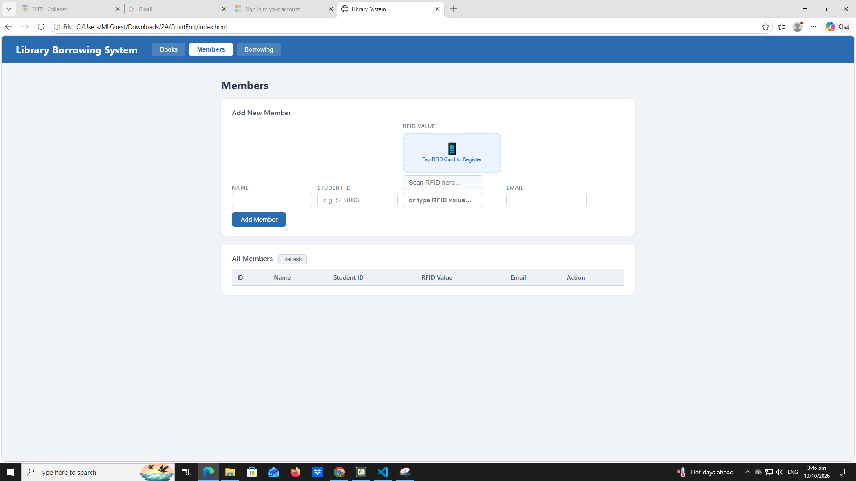

Part 05 - loadbooks

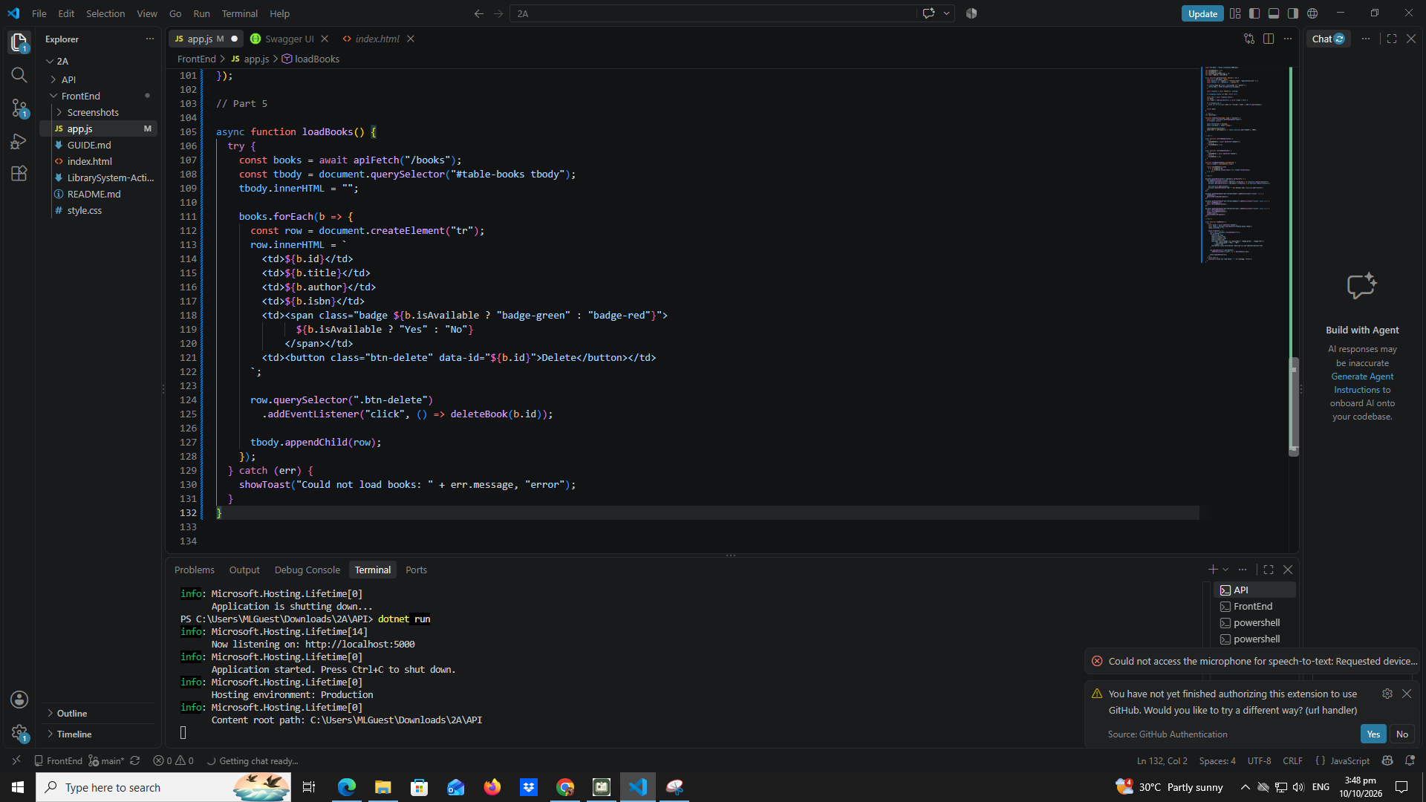

Part - 06 -deletebook
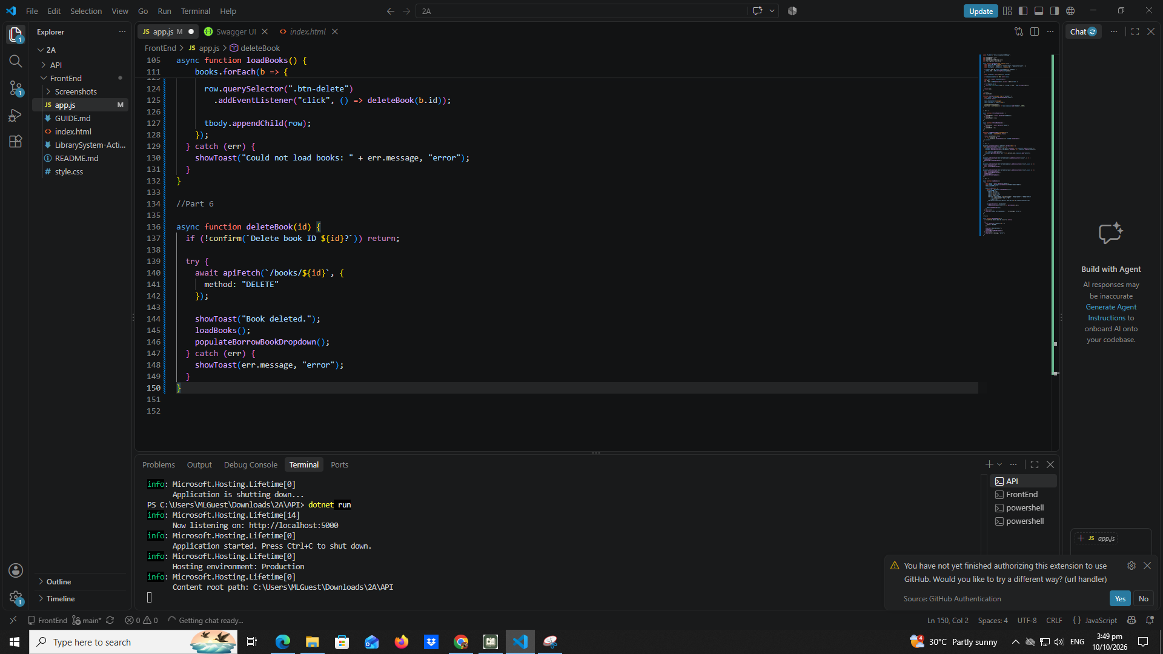

Part- 07- addBook

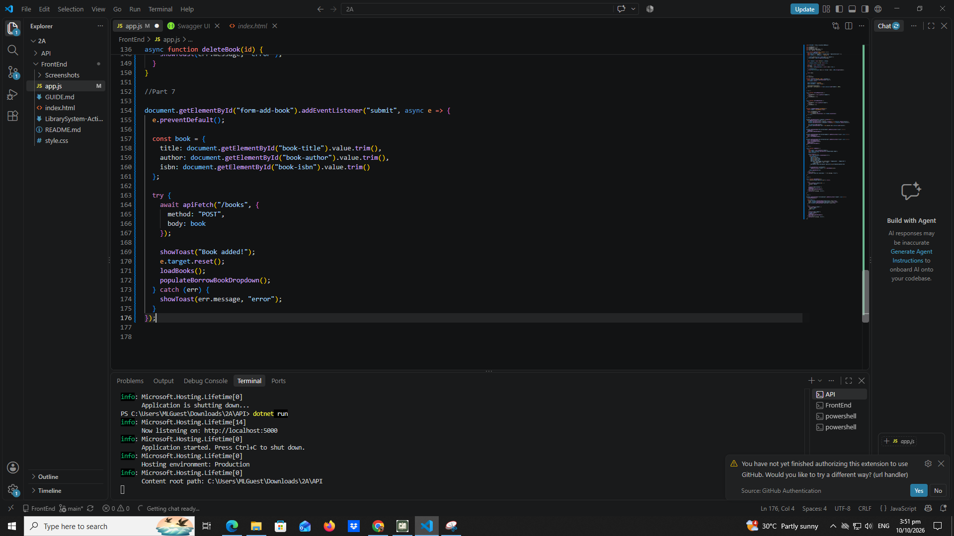

Part- 08 - LoadMembers
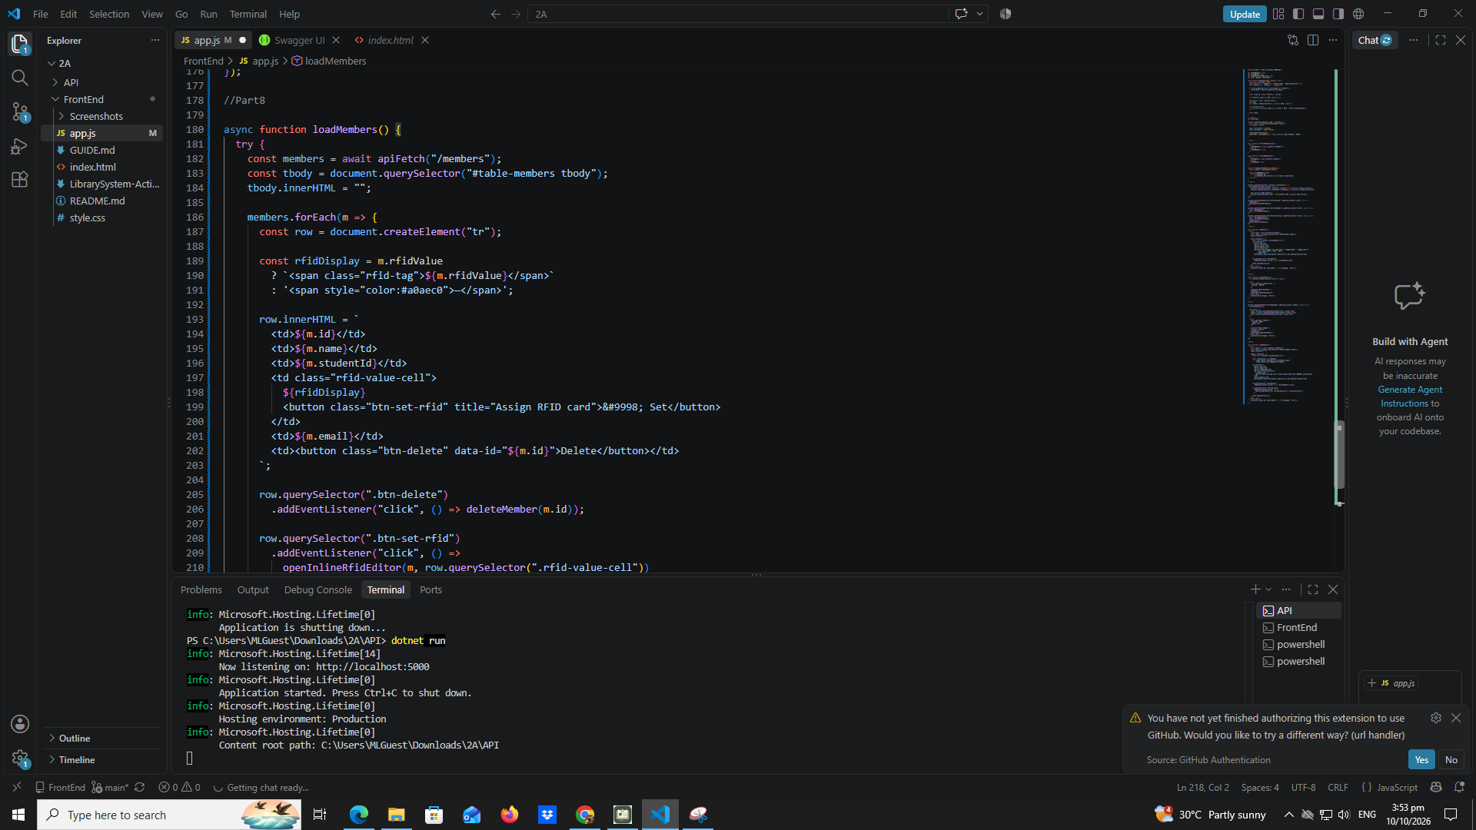

Part - 09 - Deletemember
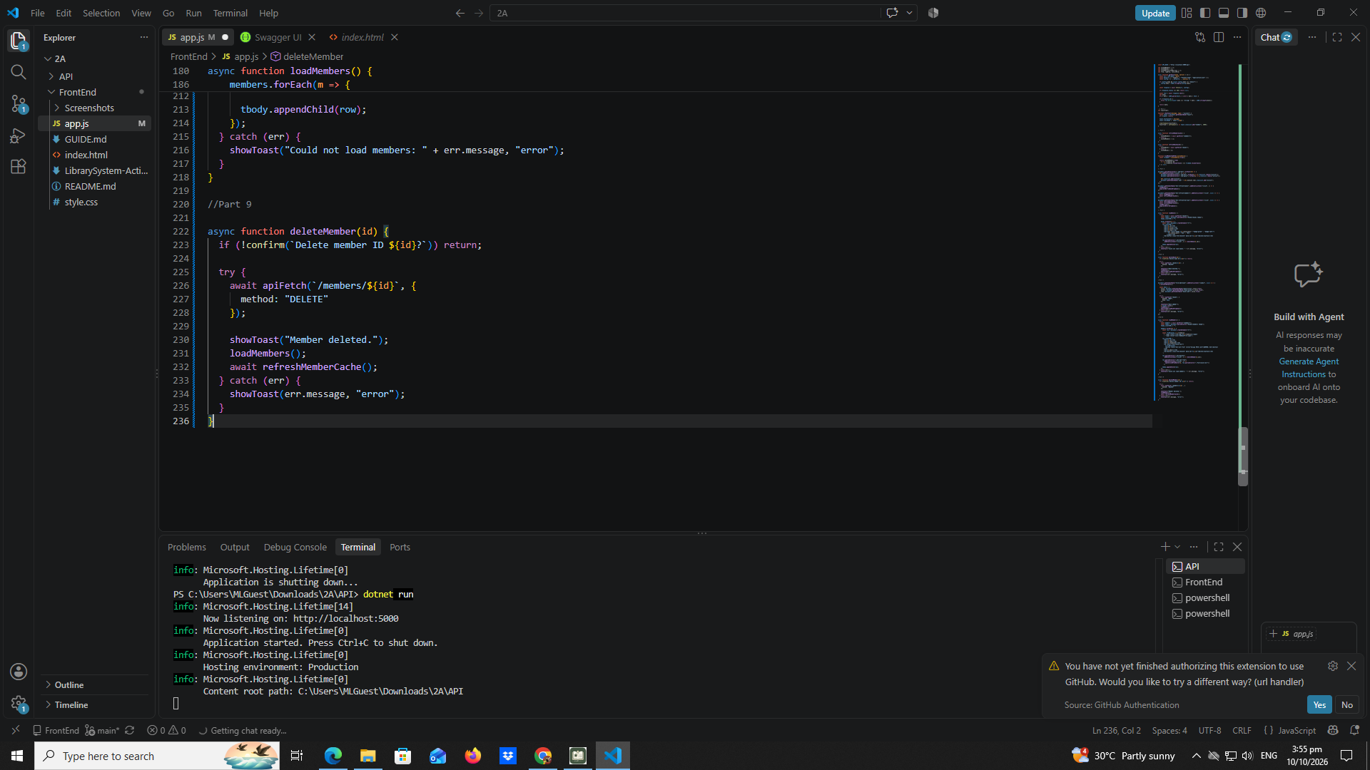

Part - 10 - addmember

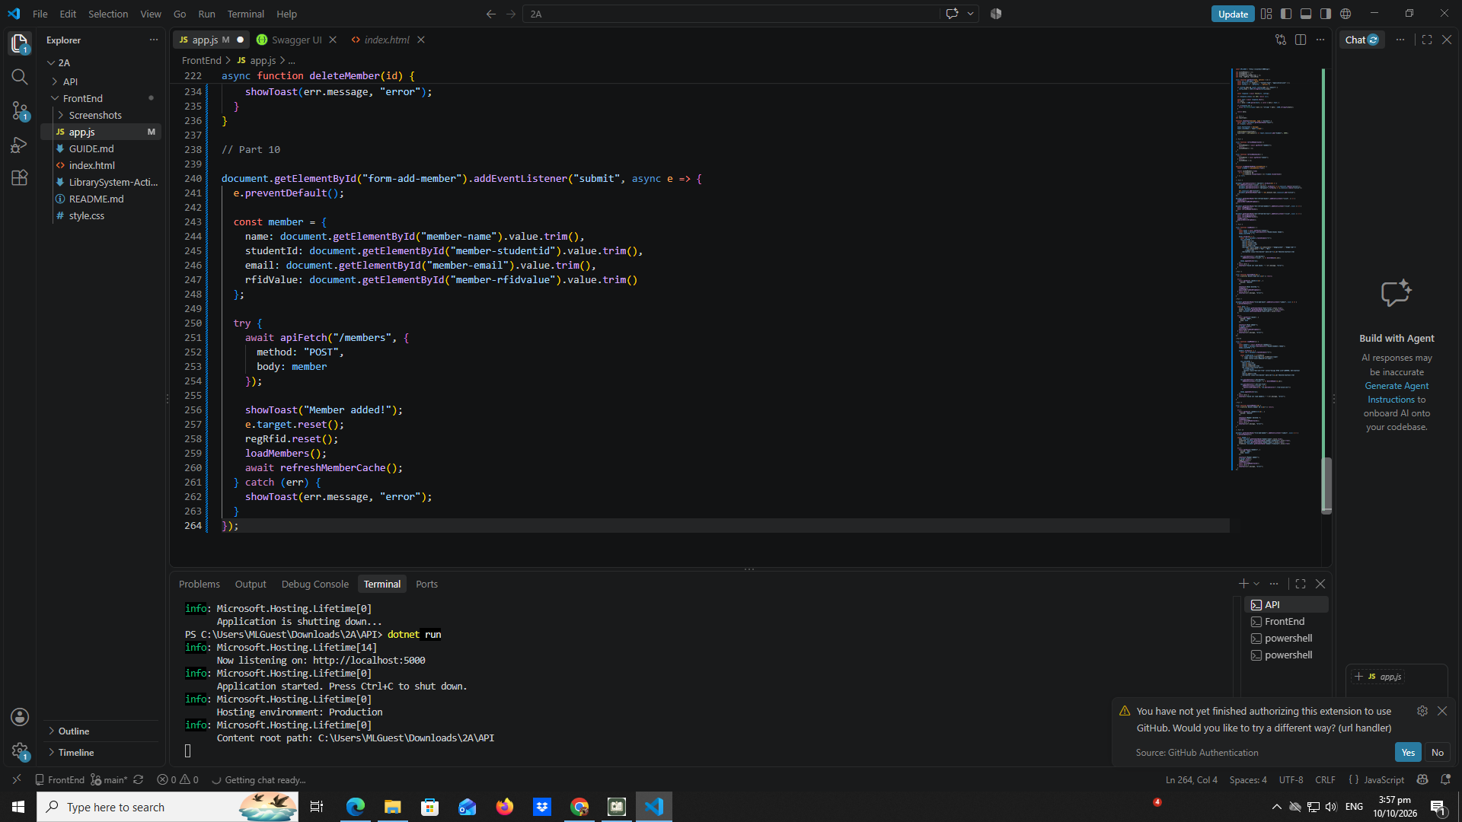

Part 11 - inline - rfid - editor

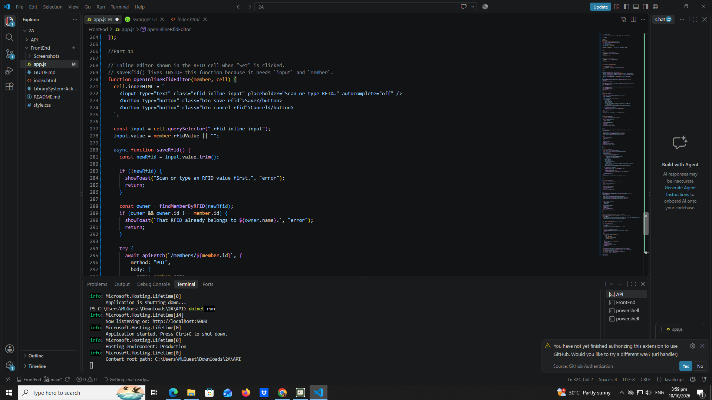

Part 12a - rfid - widget - builder

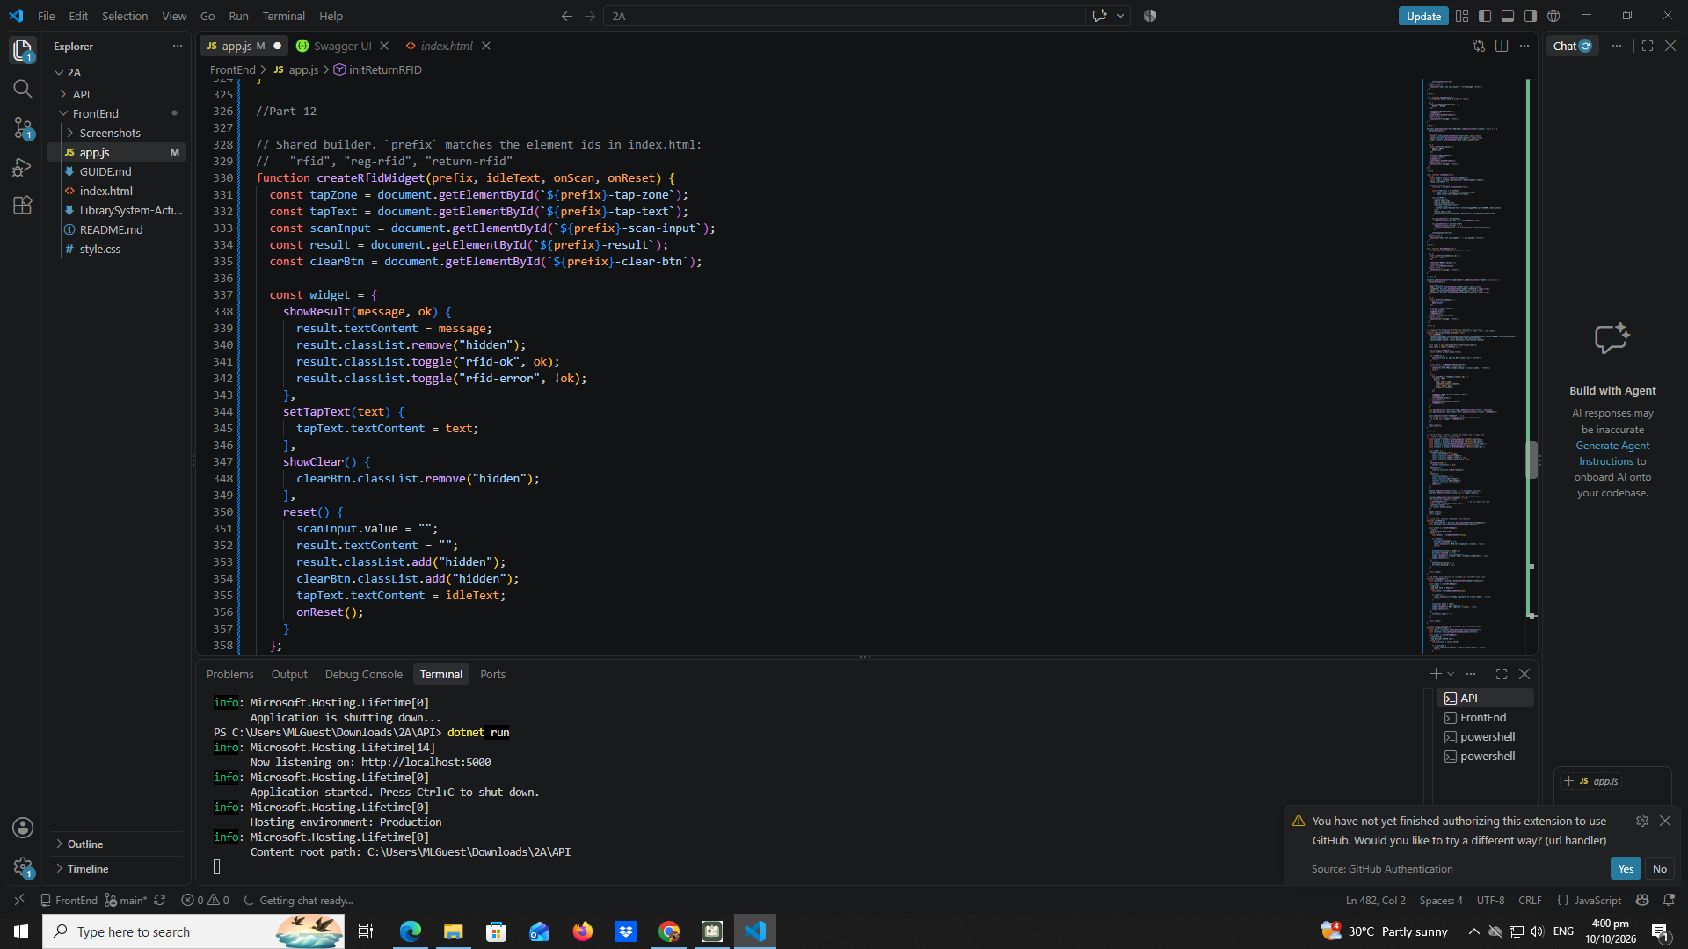

Part 13 - borrow - dropdown

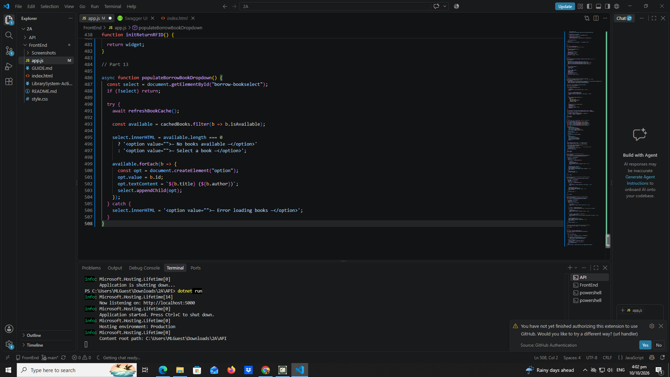

Part 14 - return - dropdown

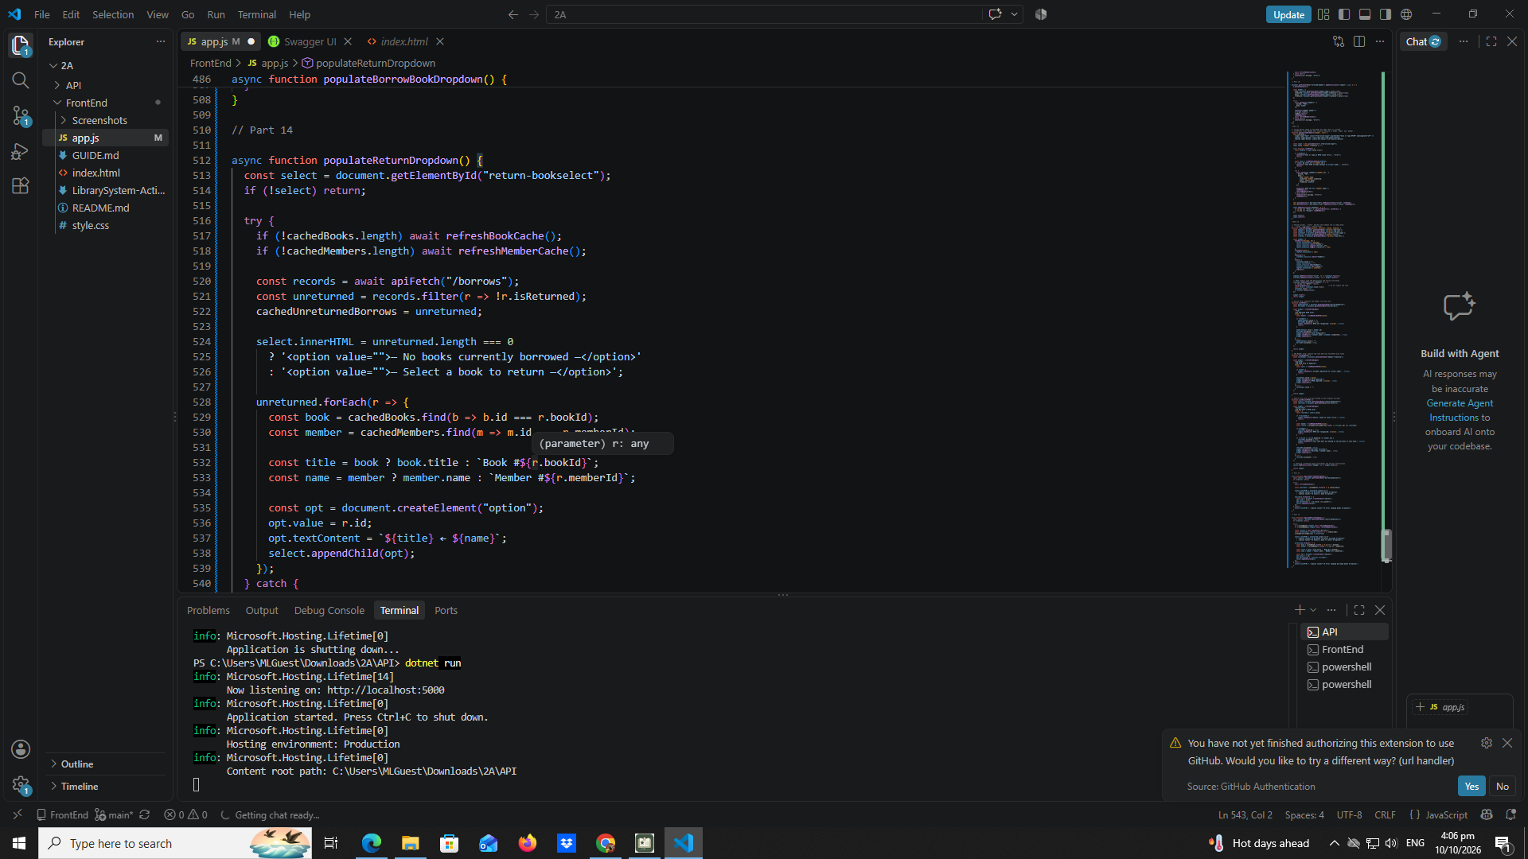

Part 15 - borrow
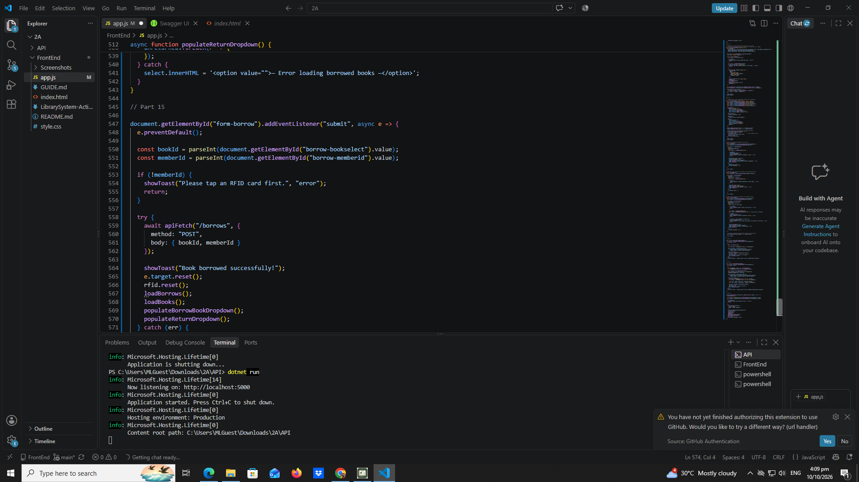

Part 16 - return
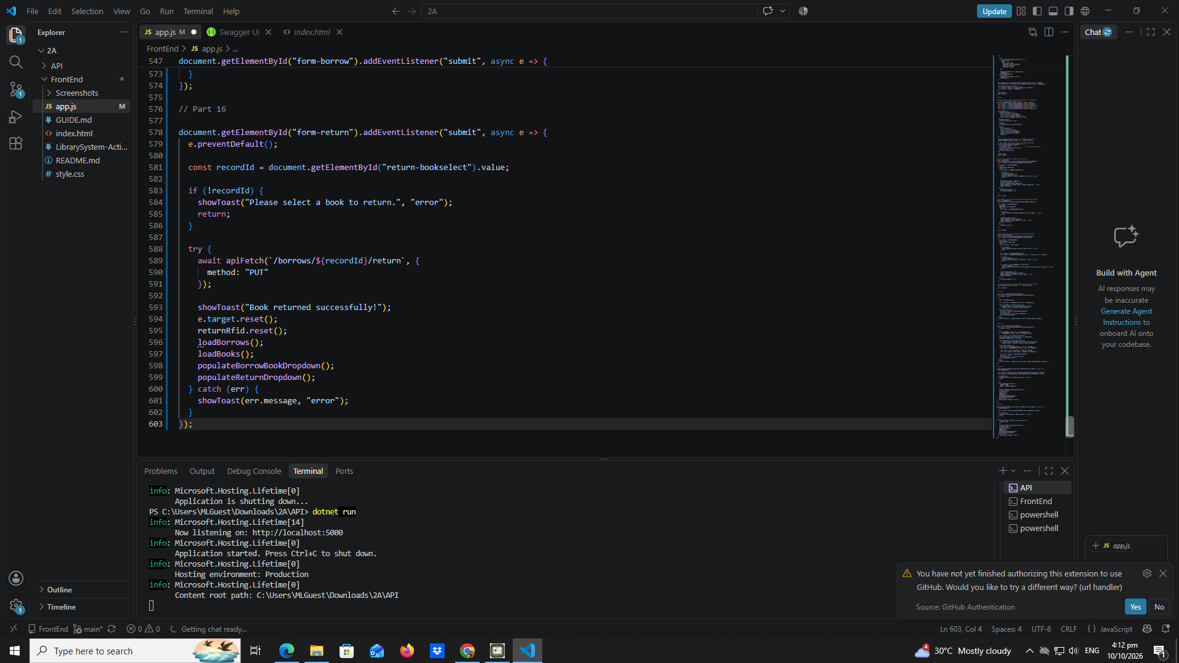

Part 17 - loadborrows

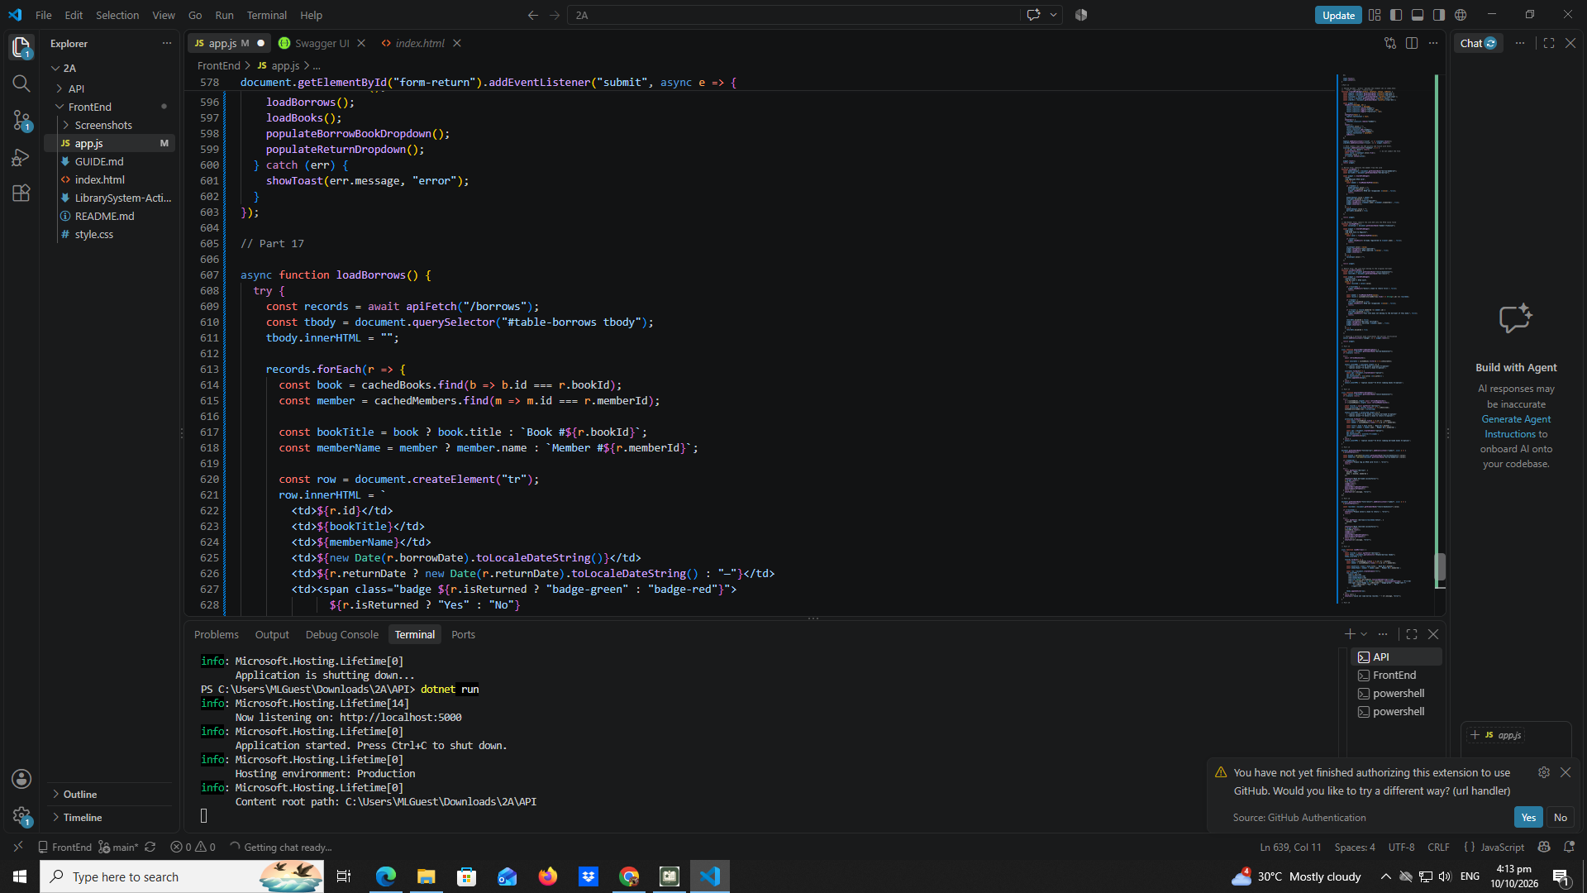

Part 18 - page - load
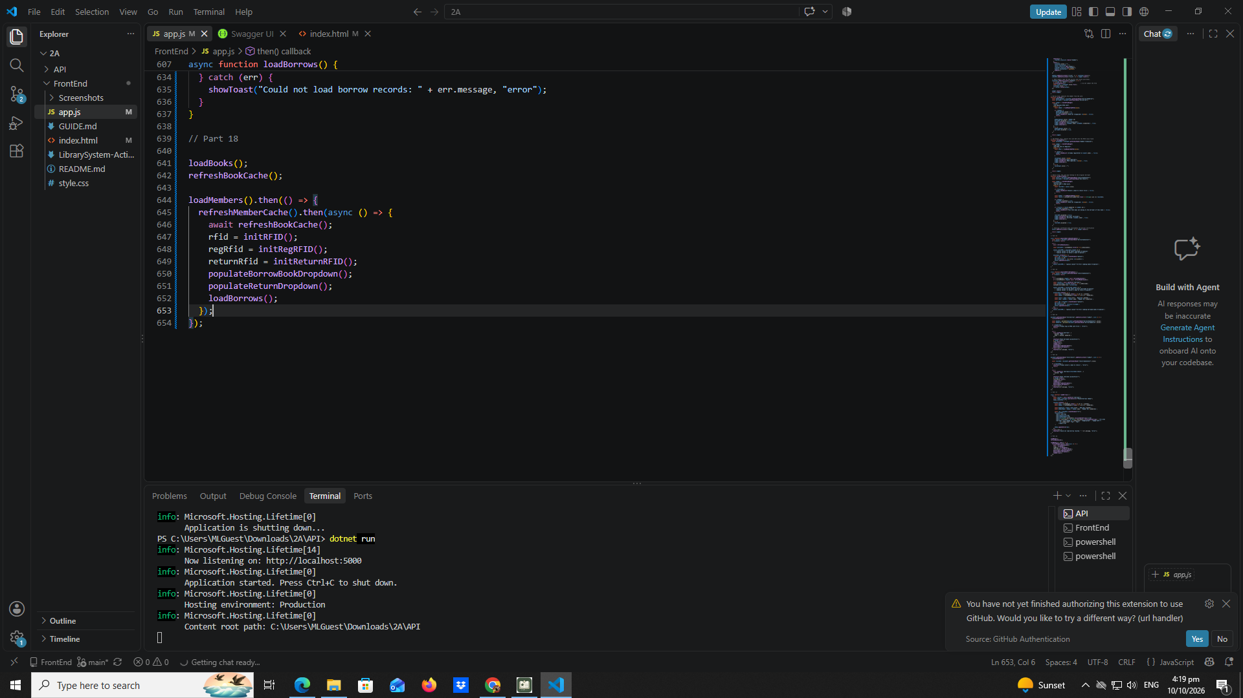

Test-01-page-loaded
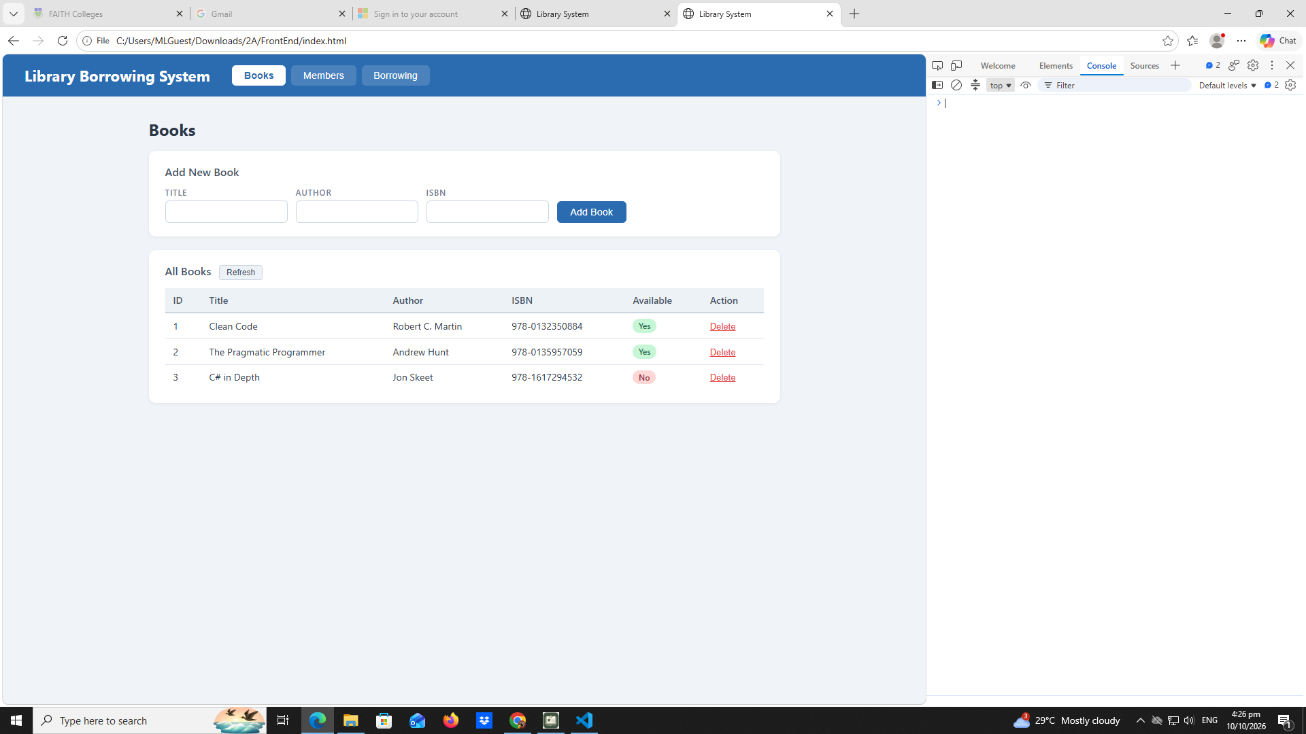

Test-02-add-book
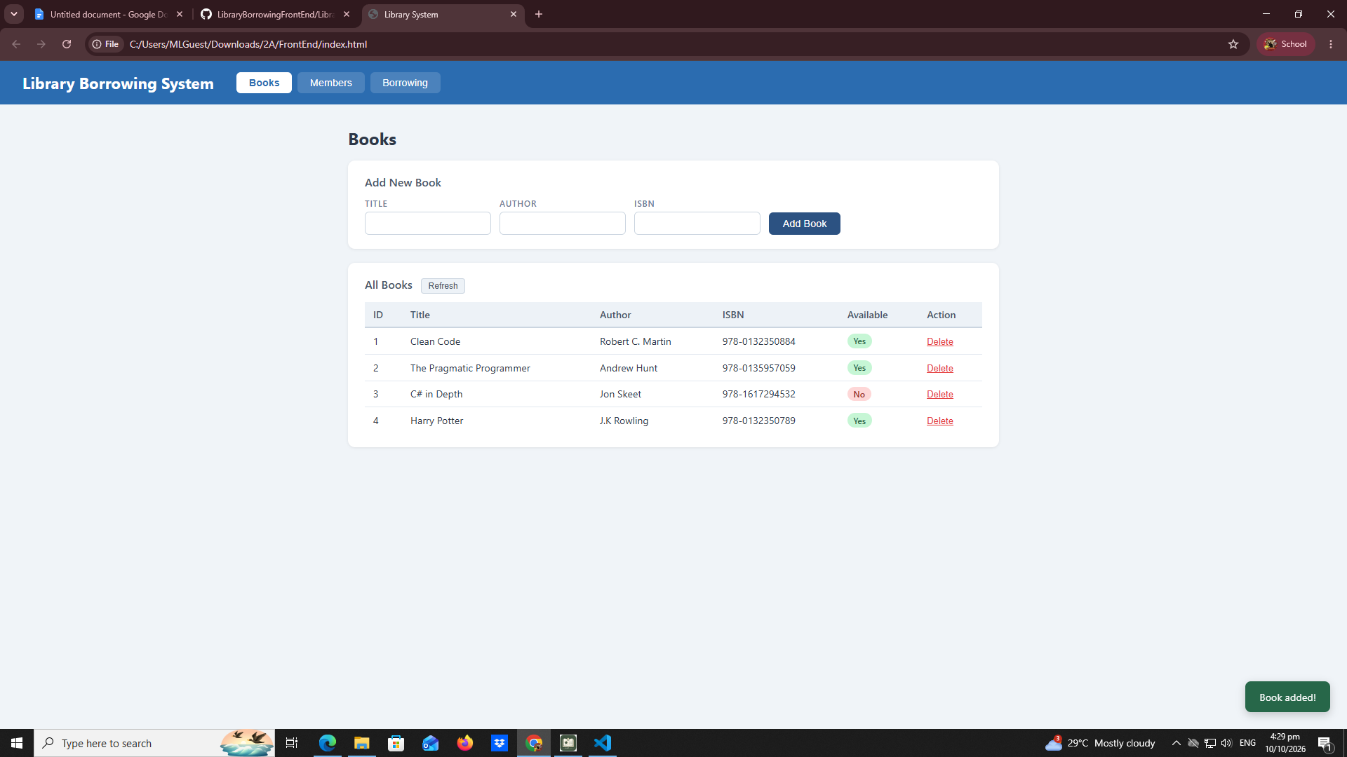
test-03-delete-book
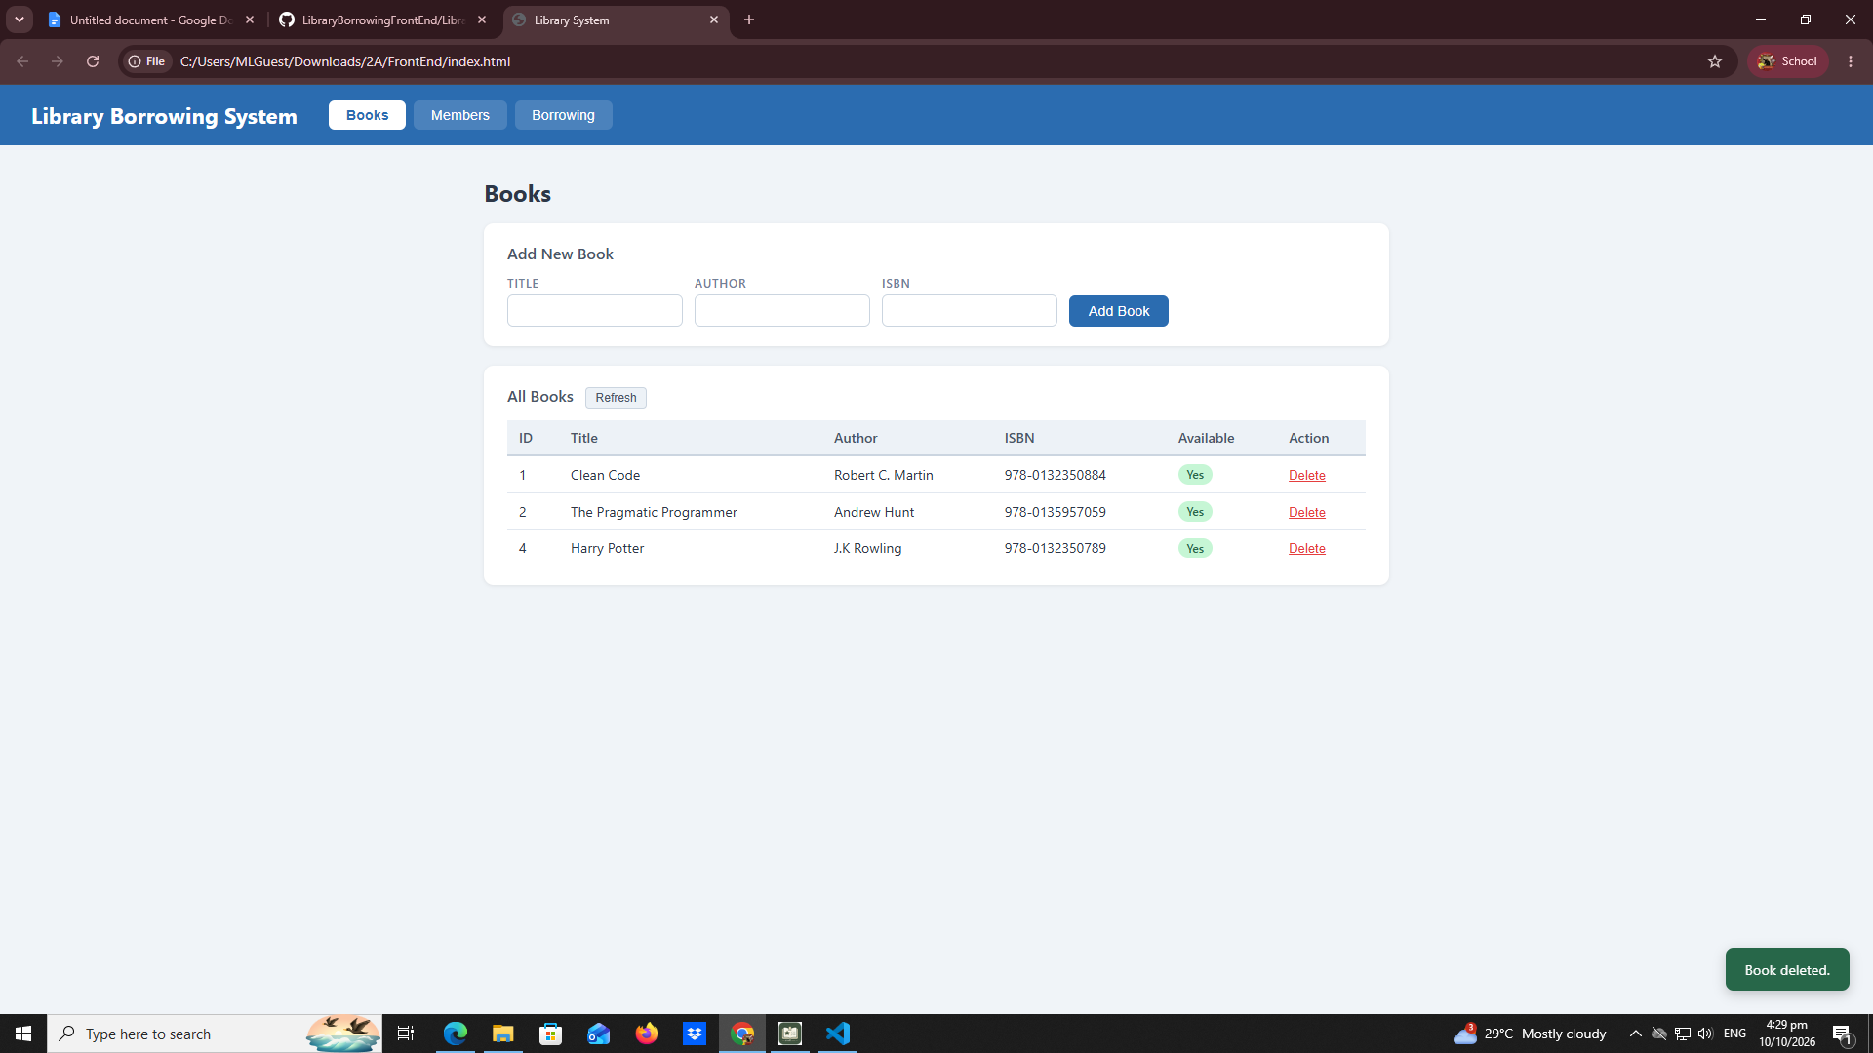

Test-04-members-loaded:
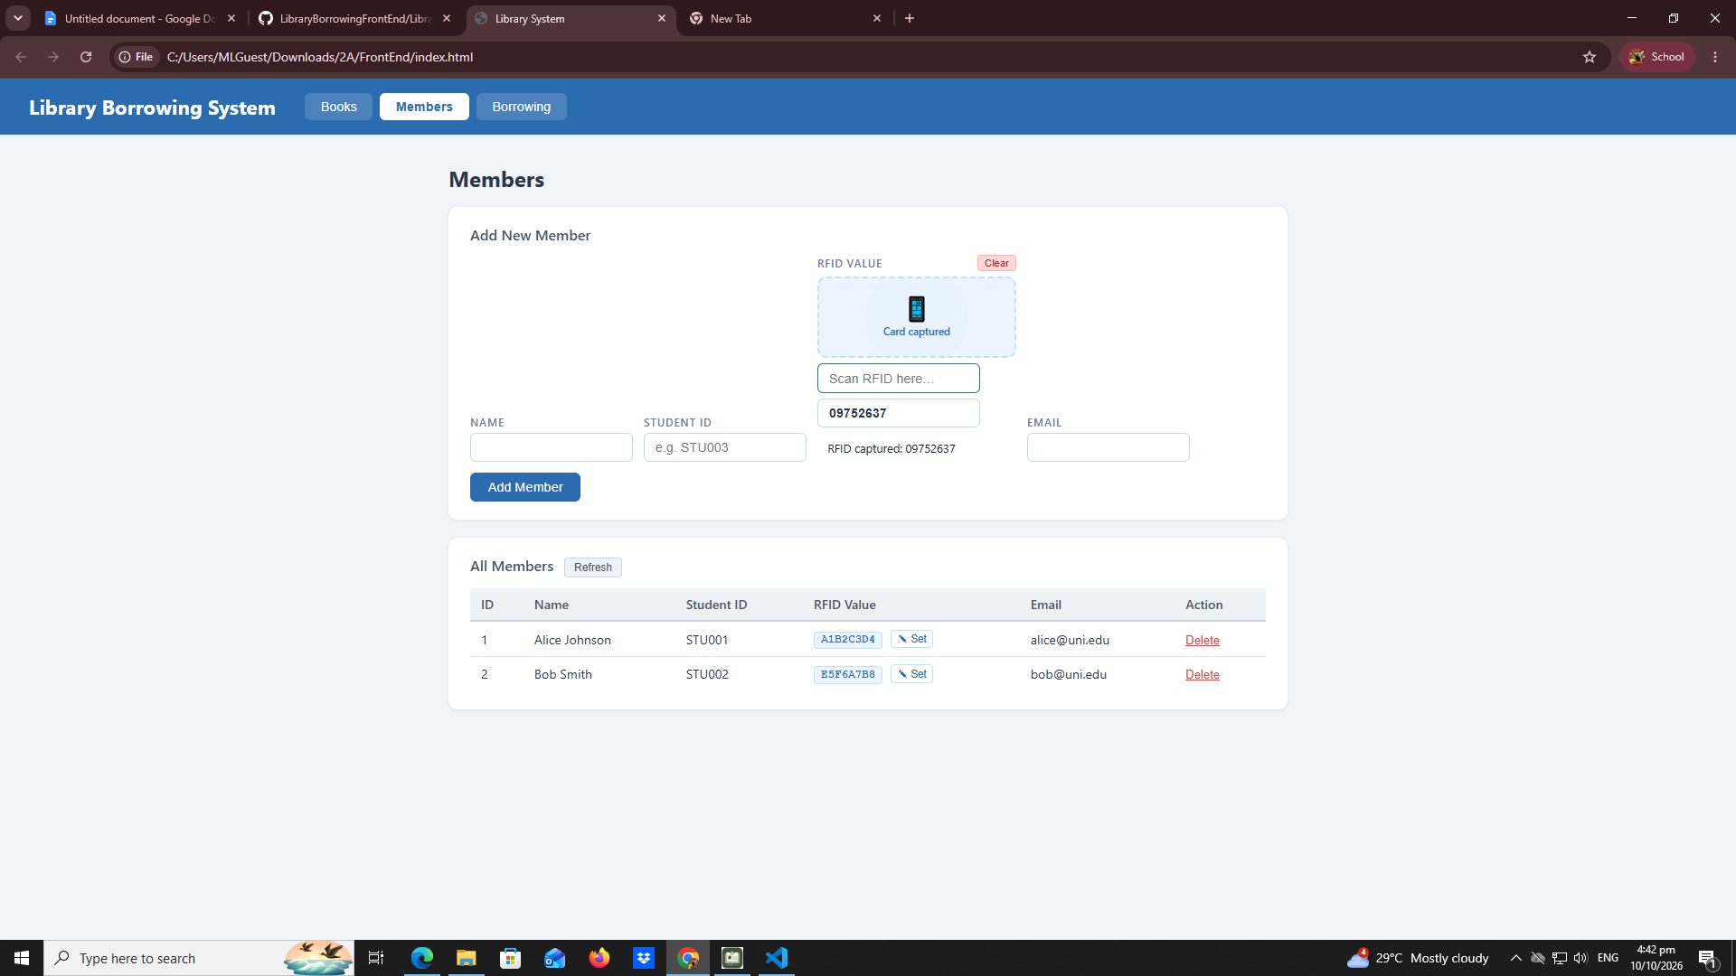

Test-05-register-rfid:
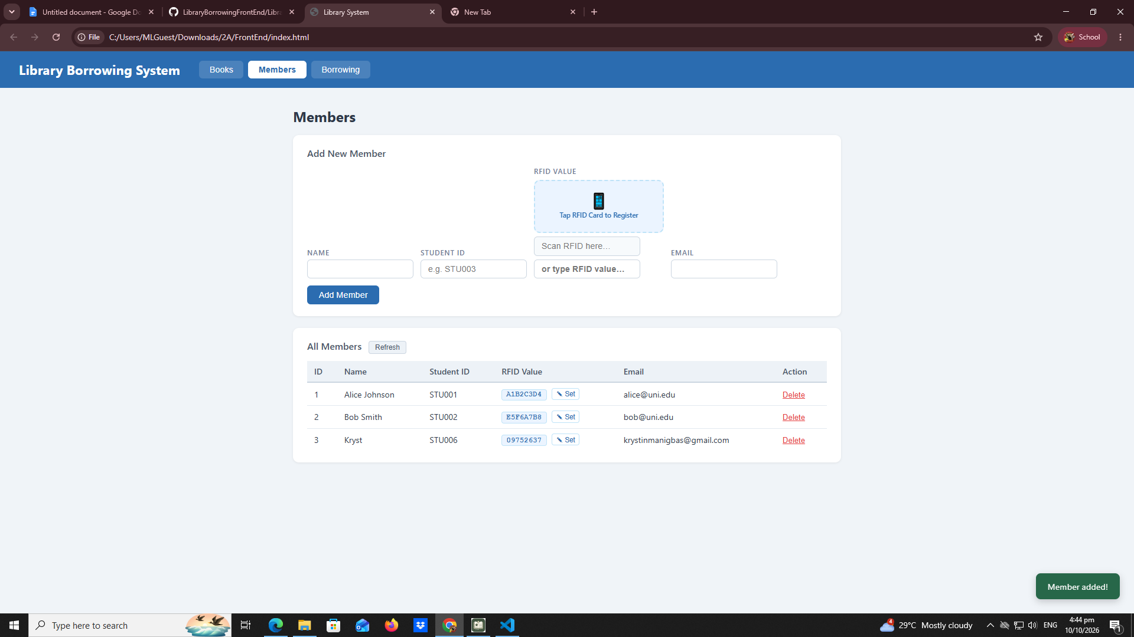

test-06-add-member:
test-07-set-rfid-saved

Test-08-delete-member:
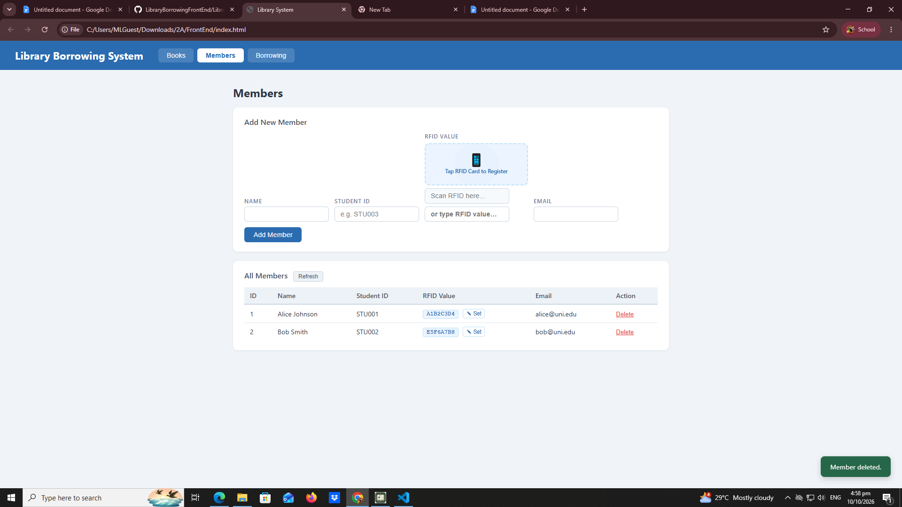

Test-09-borrow-rfid-recognized:
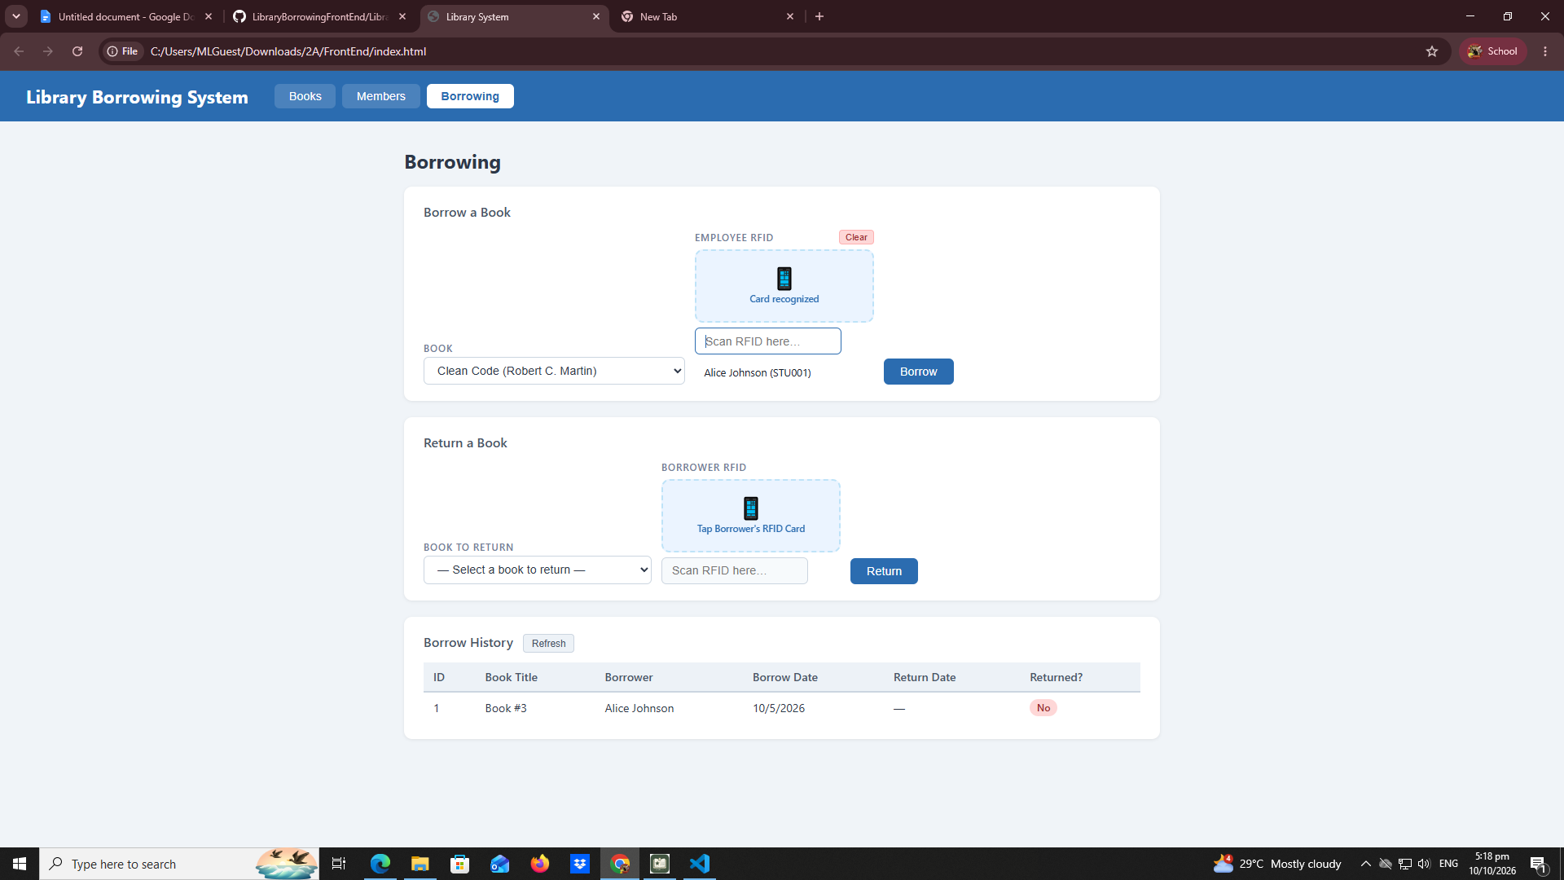
Test-10-borrow-success:
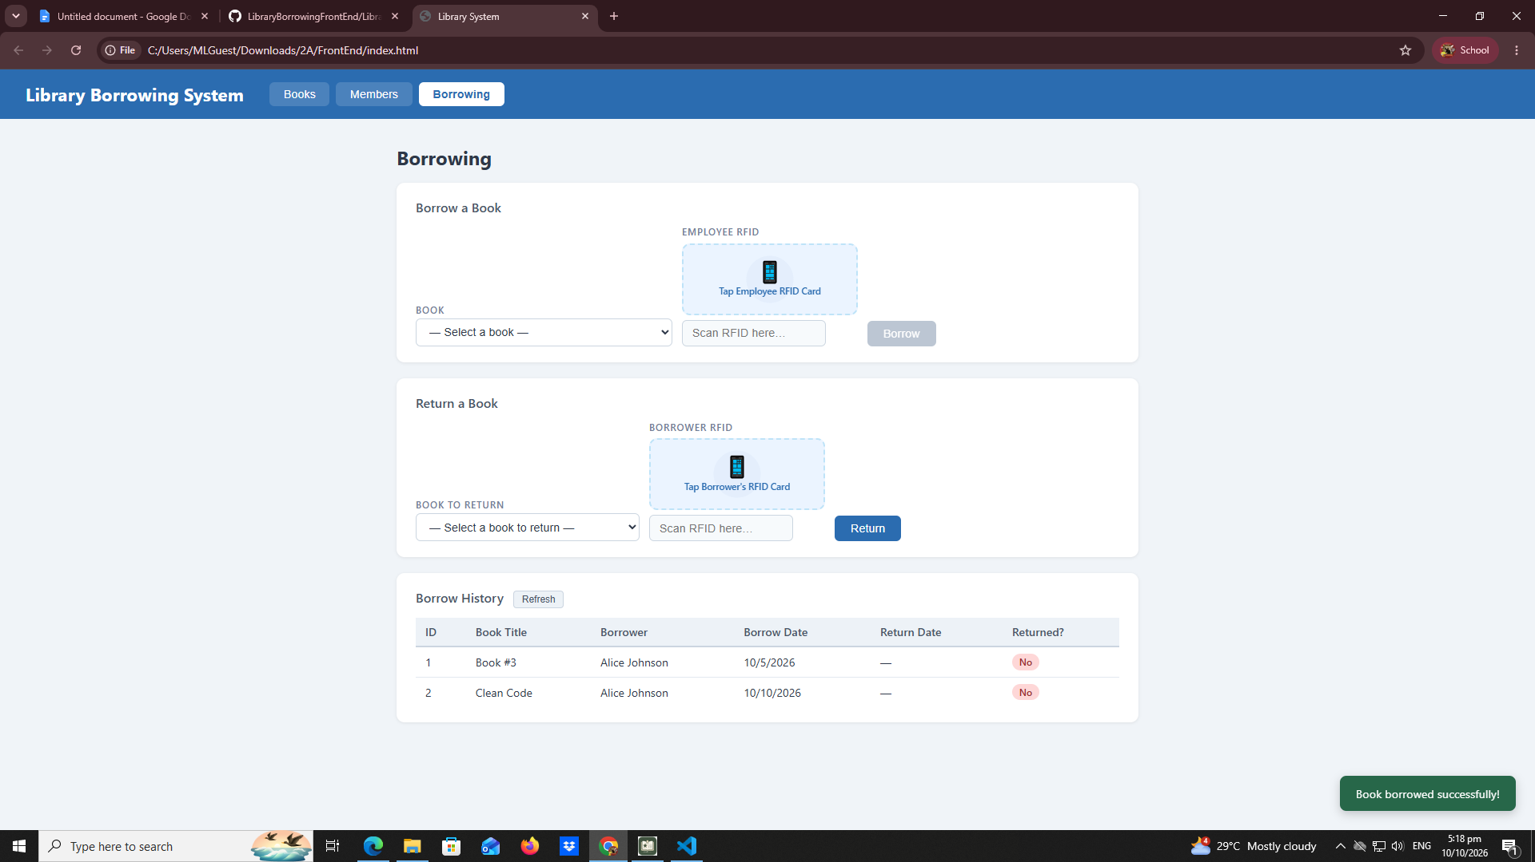

Test-11-return-wrong-card: 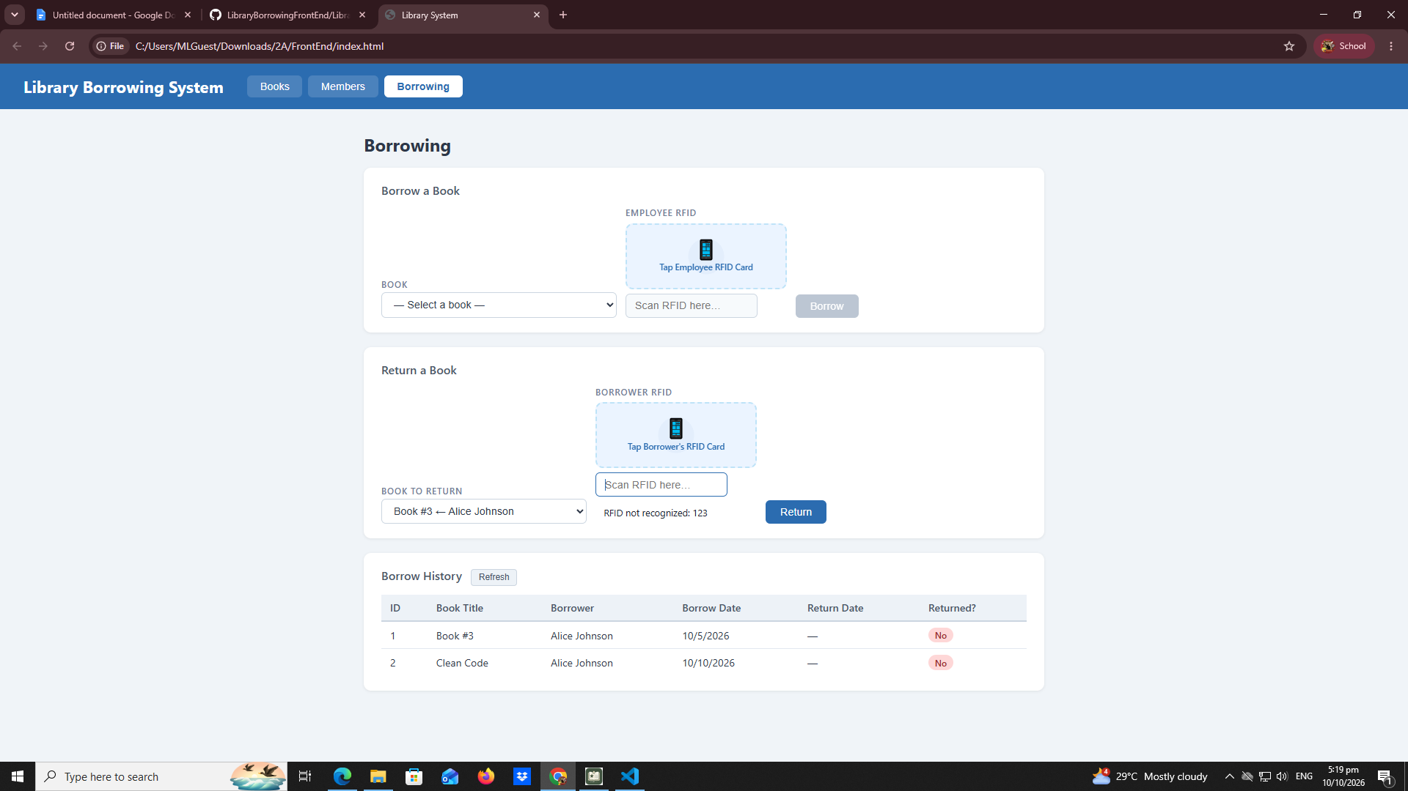

Test-12-return-verified: 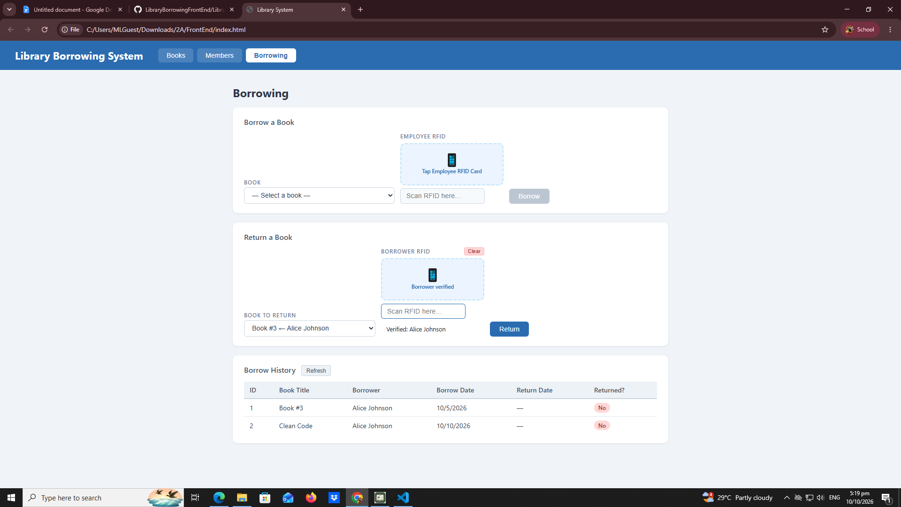

Test-13-return: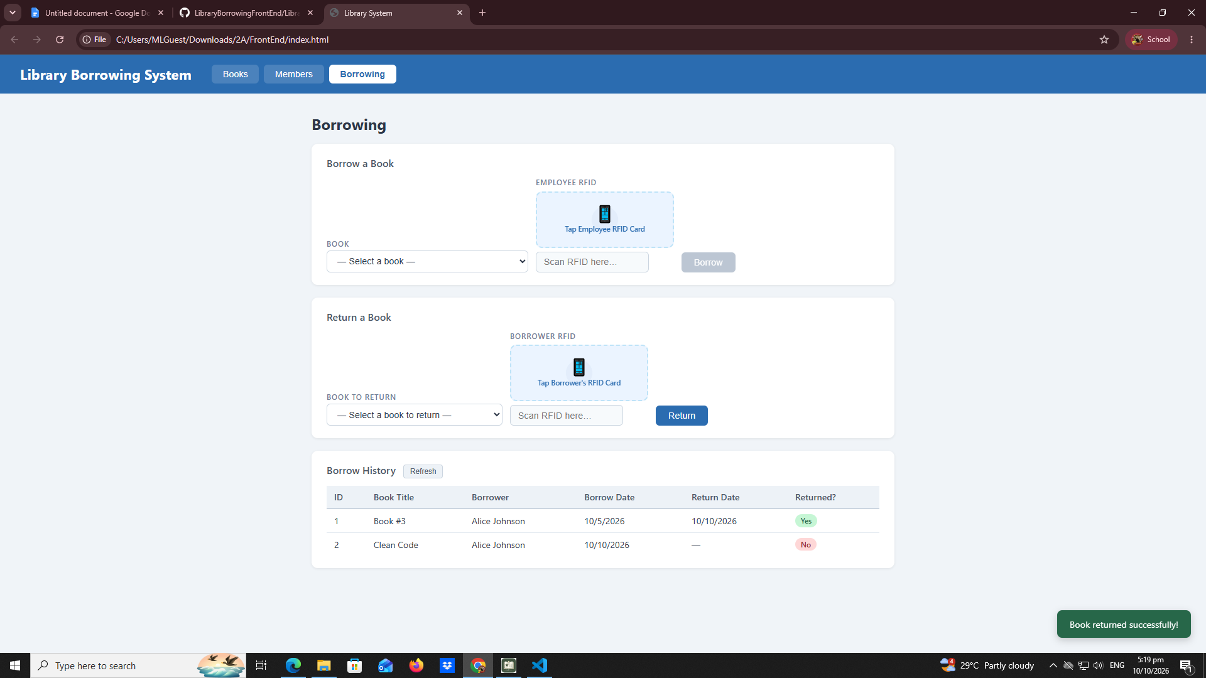

test-14-final-console: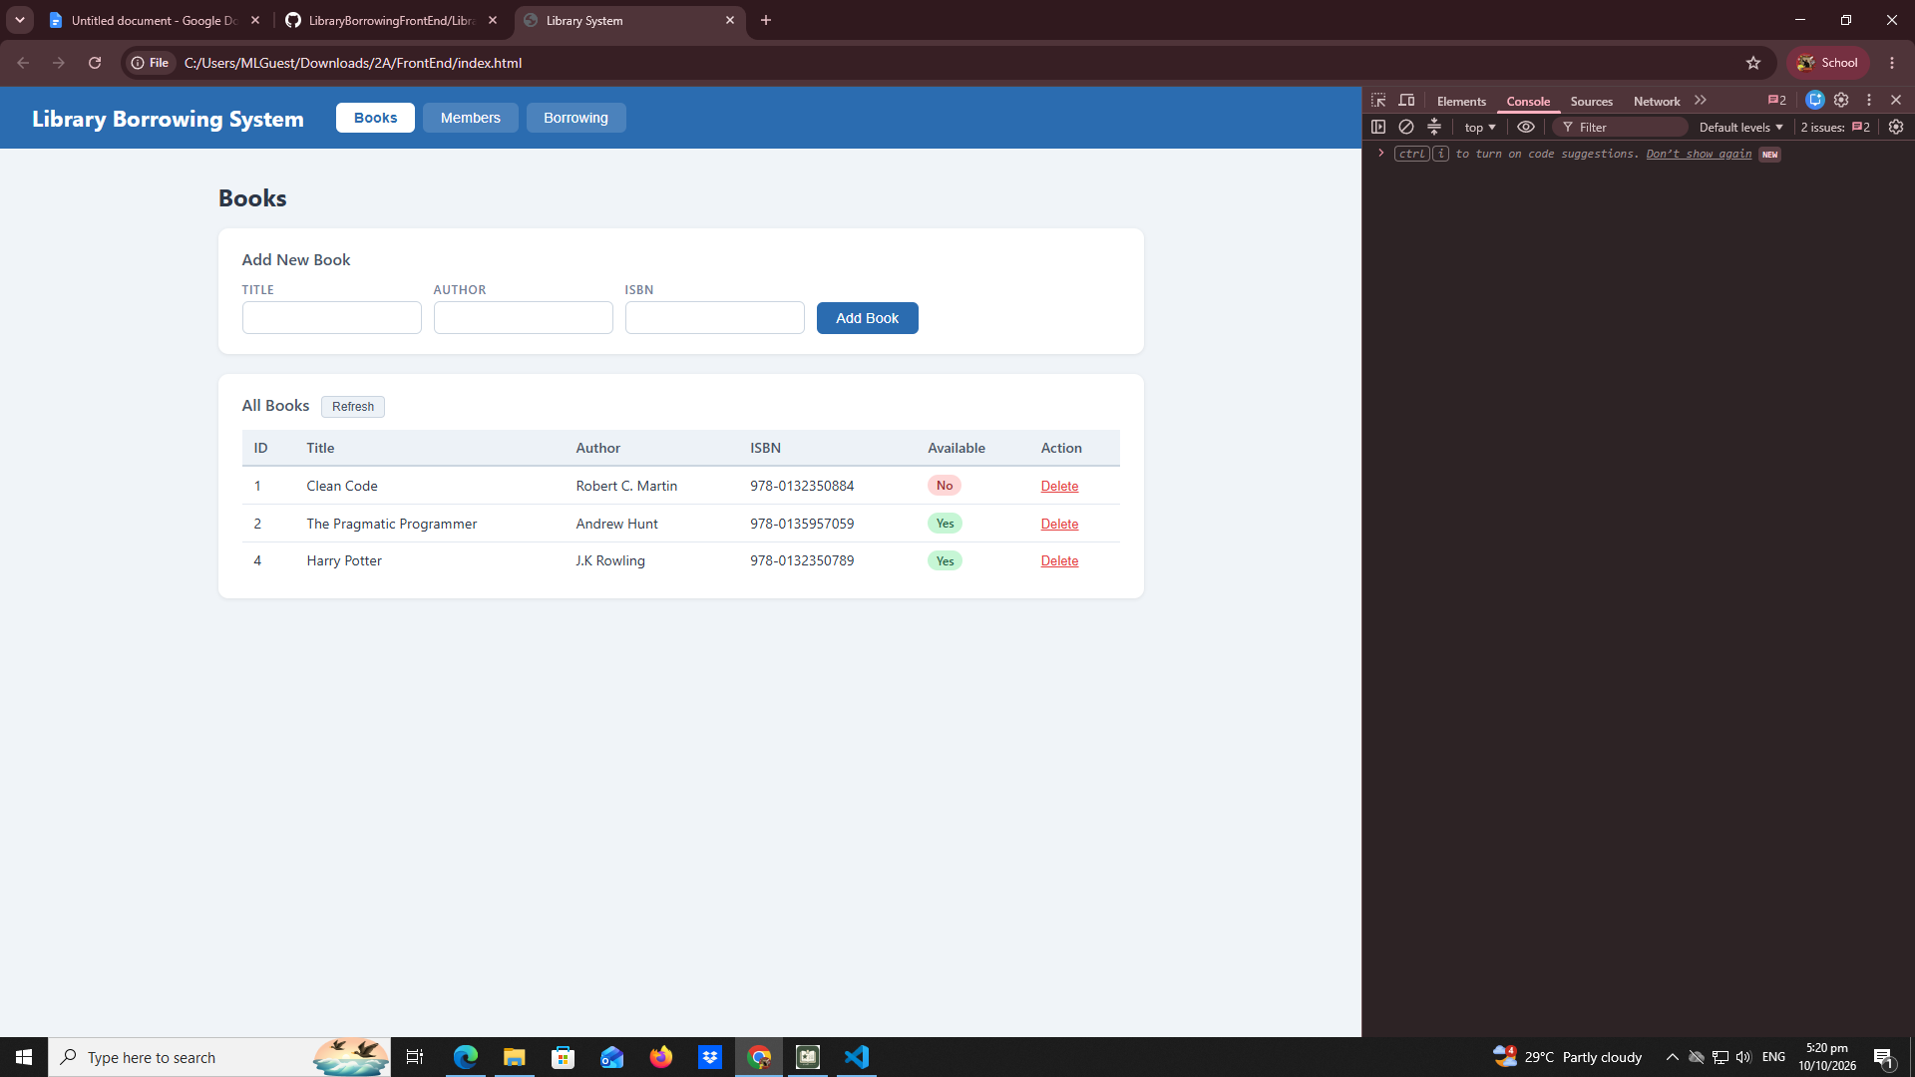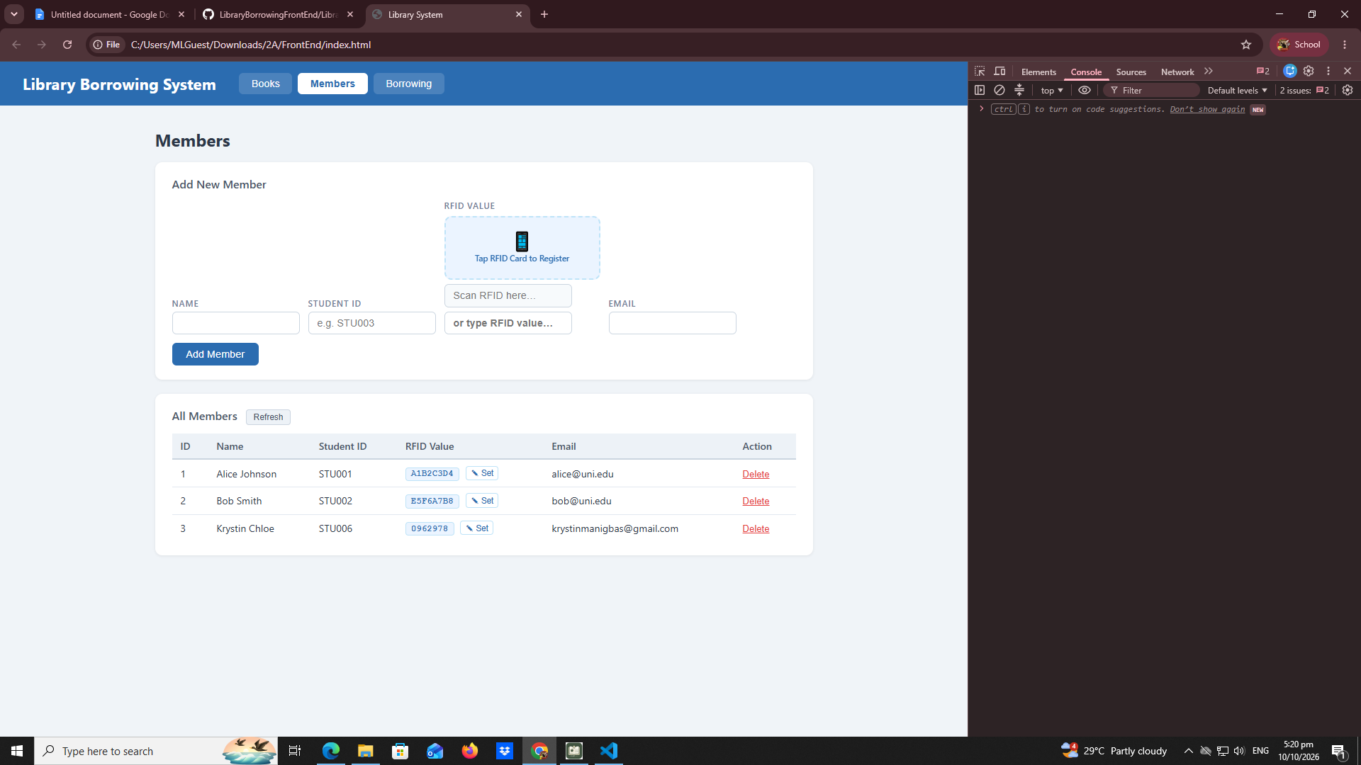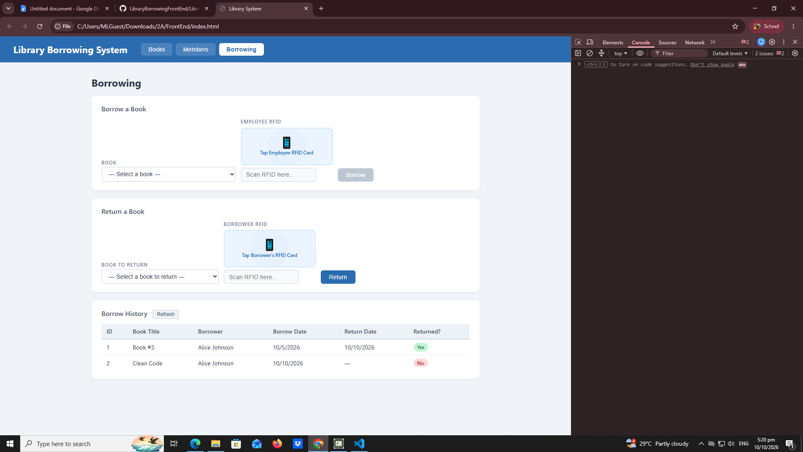

- What does apiFetch() do?
- The apiFetch does is to create reusable async API helper
- Why do we have to try/ catch around API calls?
- We have to try / catch is to convert JSON text to object
- What is the difference between POST and PUT?
- The difference between POST and PUT is that when Post is that create and Put is updating
- Why does RFID matching use rfidValue instead of studentId?
- Why do we refresh tables after adding, deleting, borrowing, or returning?
- Why does the Return dropdown use borrow record ID instead of book ID?
- What happens if the same event listener is added to a form twice?
- Why must the page-load code be at the bottom of the file?
- Why does an RFID reader need e.preventDefault() on the Enter key?

